User guide
Charging
Connect the USB cable to the USB connector on the charger. The other end of the USB cable plug in the 230 V charger and then plug it into the electric outlet (A) or the USB port of your PC / laptop (B). After connecting, the power supply starts automatically charging.
The charger EVOLVE Turbo Power allows simultaneously charging of two devices via two USB outputs (USB 1: Output 0.6A, USB 2: Output 2 A).

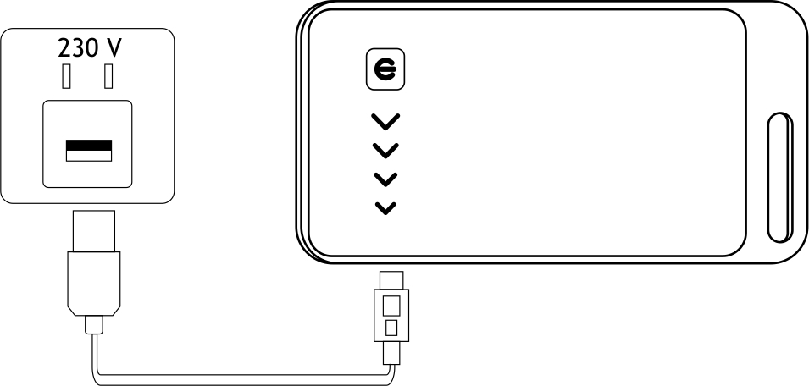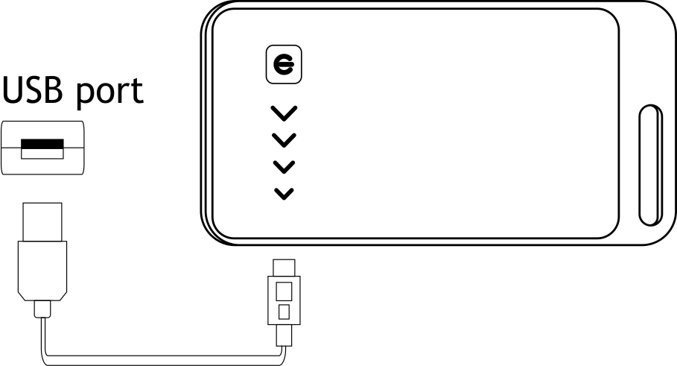
A. B.

The charge indication of the battery charger
The status of the battery charging is indicated by a blue LED on the front panel. Each of the four diodes represents a 25% charge. Once all 4 LEDs light up, the charger is fully charged. If pressing the button on the front and all LEDs are extinguished, the charger is exhausted. Holding down the button on the front for two seconds, you will activate the flashlight. In the same way, the light is possible to turn off.

Troubleshootings
No response from the charged device
a The device is not charged by 5V - check voltage.
b Improperly connected device - check the connections.
c Charging cable or connector is damaged - replace them.
d. Short circuit between input and output - protection activated - EVOLVE TurboPower connect to the charger or USB port.

Maintenance
If the charger is not in use, recharge it at least once every three months. Avoid contact with corrosive or volatile liquids. For cleaning, use a clean, dry cloth. Keep the connectors clean.

Warnings
• Use the product with the supplied adapter only
• Do not disassemble the damaged product
• Do not attempt to replace the internal battery
• Do not use the charger in a damp room or at high temperatures, such as bathrooms, sauna, swimming pool, etc.
• If you smell any odor when connected, immediately disconnect the charger from the mains or other connected device and check the
connection
• Store the charger in a dry, dust-free environment, away from heat, direct sunlight and low temperatures
• Ambient temperature has a significant influence on the battery capacity and battery life
• Do not disassemble the product under any circumstances
• Do not touch the product with wet hands
• Do not expose the charger to heavy mechanical stress
• Keep the product out of the children

Technical specification
Input voltage: 5,1 V | Maximum output current: 2000 mA
Maximum input current: 1000 mA | Dimensions: 60 x 110.5 x 14 mm
Capacity: 5200 mAh | Weight (netto): 110 g
Output voltage: 5,1 V

